AKNOWLEDGEMENTS

We would like to thank our principal Mrs. Shantha Chandran for giving us the opportunity to display our talents. We would like to thank our teachers who helped us and guided us through the project. We would also like to thank our parents who always encouraged and supported us.

Introduction

This program is an entertaining game for kids based on the game Dragon Ball Z. It is a multiplayer platform fighting game using pygame and other modules of python. IT comes packed with exclusive features like multiple characters and a never before seen fight scene and phenomenal game play and a unique high score system that will blow you away.

System requirements

**Hardware requirements**:

* Pentium processor/higher with 2 GB RAM
* Mouse
* Keyboard
* Color Monitor

**Software requirements:**

* Operating system – Windows XP or higher
* Python version 2.7.4 or higher

List of Modules

|  |  |
| --- | --- |
| Module Name | Library Functions |
| pygame | blit(),image.load(),Rect(),mixer.music.play(),font.Sysfont() |
| copy | deepcopy() |
| time | sleep() |

List of User Defined Functions

|  |  |
| --- | --- |
| Funtion Name | Task |
| highscore() | Shows and stores highscore using file handling |
| move() | Controls the character on screen |
| attmov() | Controls attack damage and attack |

List of Data Types

|  |  |
| --- | --- |
| DataType | Name |
| Integer | Healthvalue1,healthvalue2,charge1,charge2,self.t |
| String | Self.name1,self.name2 |
| List | Keys1,keys2,playerpos1,playerpos2 |

Algorithm

START

Enter name of players

Select character by mouse input

New screen start with both characters and health bars

Movement and attack control by keyboard input

Damage detected using hitboxes and healthbar changed

If health1 or health2 less than 0

1

YES NO

STOP

1

Window for end credits

highscore and winner dislayed

Source Code

'''This program is an entertaining game for kids based on the game Dragon Ball Z.

It is a multiplayer platform fighting game using pygame and other modules of python.'''

#importing modules

import pygame

import copy

import time

healthvalue1=200

healthvalue2=200

#Class for highscore

def highscore(n1,n2,w):

f1=open('Highscore.txt','a+')

f1.write('\n'+n1+' '+n2+' '+w)

f1.flush()

f1.seek(0)

score=f1.read()

return score.split('\n')

#Class for defining players attributes

class player:

def __init__(self,name1,name2):

self.name1 = name1

self.charge1=0

self.bg=pygame.image.load('Background.JPG')

self.attno1=0

self.name2 = name2

self.charge2=0

self.attno2=0

#Assigning image variables for player1

if self.name1 == 'goku':

self.image1=pygame.image.load('goku/goku.png')

self.ch1=pygame.image.load('goku/charge.png')

self.att1=pygame.image.load('goku/kamehameha2.png')

self.uatt1=pygame.image.load('goku/hame goku.png')

elif self.name1=='vegeta':

self.image1=pygame.image.load('vegeta/vegeta.png')

self.ch1=pygame.image.load('vegeta/vch.png')

self.att1=pygame.image.load('vegeta/vab2ch.png')

self.uatt1=pygame.image.load('vegeta/vff.png')

elif self.name1=='pikkon':

self.image1=pygame.image.load('pikkon/pikkon.png')

self.ch1=pygame.image.load('pikkon/pcharge.png')

self.att1=pygame.image.load('pikkon/pturnado.png')

self.uatt1=pygame.image.load('pikkon/pfinish.png')

elif self.name1=='frieza':

self.image1=pygame.image.load('frieza/frieza.png')

self.ch1=pygame.image.load('frieza/frch.png')

self.att1=pygame.image.load('frieza/dball.png')

self.uatt1=pygame.image.load('frieza/beam.png')

elif self.name1 == 'vader':

self.image1=pygame.image.load('vader/vader.png')

self.ch1=pygame.image.load('vader/charge.png')

self.att1=pygame.image.load('vader/saberthrow.png')

self.uatt1=pygame.image.load('vader/lightning.png')

#Assigning image variables for player2

if self.name2 == 'goku':

self.image2=pygame.image.load('goku/gokuf.png')

self.ch2=pygame.image.load('goku/chargef.png')

self.att2=pygame.image.load('goku/kamehameha2.png')

self.uatt2=pygame.image.load('goku/hame goku f.png')

elif self.name2 == 'vegeta':

self.image2=pygame.image.load('vegeta/vegetaf.png')

self.ch2=pygame.image.load('vegeta/vchf.png')

self.att2=pygame.image.load('vegeta/vab2ch.png')

self.uatt2=pygame.image.load('vegeta/vfff.png')

elif self.name2 == 'pikkon':

self.image2=pygame.image.load('pikkon/pikkonf.png')

self.ch2=pygame.image.load('pikkon/pchargef.png')

self.att2=pygame.image.load('pikkon/pturnado.png')

self.uatt2=pygame.image.load('pikkon/pfinishf.png')

elif self.name2 == 'frieza':

self.image2=pygame.image.load('frieza/friezaf.png')

self.ch2=pygame.image.load('frieza/frchf.png')

self.att2=pygame.image.load('frieza/dball.png')

self.uatt2=pygame.image.load('frieza/beamf.png')

elif self.name2 == 'vader':

self.image2=pygame.image.load('vader/vaderf.png')

self.ch2=pygame.image.load('vader/charge.png')

self.att2=pygame.image.load('vader/saberthrow.png')

self.uatt2=pygame.image.load('vader/lightning.png')

self.player1=self.image1

self.player2=self.image2

#Getting rectanges of player images

self.player1rect=pygame.Rect(self.image1.get_rect())

self.player2rect=pygame.Rect(self.image2.get_rect())

#Loading images for healthbar and chargebar

self.healthbar = pygame.image.load("healthbar.png")

self.health = pygame.image.load("health.png")

self.chargebar = pygame.image.load("chargebar.png")

self.mana = pygame.image.load("mana.png")

self.t=0

def move(self): #Function to move the charaters

global healthvalue1,healthvalue2,n1,n2

self.player1pos=[100,512]

keys1=[False,False,False,False,False,False]

self.player2pos=[680,512]

keys2=[False,False,False,False,False,False]

temp=0

pygame.mixer.music.play(-1)

while 1:

#Main screen and background

screen.blit(self.bg,[0,0])

screen.blit(self.player1,self.player1pos)

screen.blit(self.player2,self.player2pos)

#'Fight' picture displaying

self.t+=1

if self.t<30:

screen.blit(pygame.image.load('fight.png'),[350,100])

#Putting players on screen

pygame.key.set_repeat(0,0)

#Player1 health bar

screen.blit(self.healthbar,[20,5])

for health1 in range(healthvalue1):

screen.blit(self.health, (health1+23,8))

#Player2 health bar

screen.blit(self.healthbar,[1000,5])

for health2 in range(healthvalue2):

screen.blit(self.health, (health2+1003,8))

#Player1 charge bar

screen.blit(self.chargebar,[20,20])

for charge in range(self.charge1):

screen.blit(self.mana, (charge+23,23))

#Player2 charge bar

screen.blit(self.chargebar,[1000,20])

for charge in range(self.charge2):

screen.blit(self.mana, (charge+1003,23))

#Cheking for key presses and other events

for event in pygame.event.get():

if event.type==pygame.QUIT:

pygame.quit()

exit(0)

#Player1

if pygame.key.get_pressed()[pygame.K_w]:

keys1[0]=True

else:

keys1[0]=False

if pygame.key.get_pressed()[pygame.K_a]:

keys1[1]=True

else:

keys1[1]=False

if pygame.key.get_pressed()[pygame.K_s]:

keys1[2]=True

else:

keys1[2]=False

if pygame.key.get_pressed()[pygame.K_d]:

keys1[3]=True

else:

keys1[3]=False

if pygame.key.get_pressed()[pygame.K_q] and pygame.key.get_pressed()[pygame.K_w]==False and pygame.key.get_pressed()[pygame.K_a]==False and pygame.key.get_pressed()[pygame.K_s]==False and pygame.key.get_pressed()[pygame.K_d]== False and self.attno1!=1:

keys1[4]=True

else:

keys1[4]=False

if pygame.key.get_pressed()[pygame.K_v] and pygame.key.get_pressed()[pygame.K_w]==False and pygame.key.get_pressed()[pygame.K_a]==False and pygame.key.get_pressed()[pygame.K_s]==False and pygame.key.get_pressed()[pygame.K_d]== False:

keys1[5]=True

else:

keys1[5]=False

#Player2

if pygame.key.get_pressed()[pygame.K_UP]:

keys2[0]=True

else:

keys2[0]=False

if pygame.key.get_pressed()[pygame.K_LEFT]:

keys2[1]=True

else:

keys2[1]=False

if pygame.key.get_pressed()[pygame.K_DOWN]:

keys2[2]=True

else:

keys2[2]=False

if pygame.key.get_pressed()[pygame.K_RIGHT]:

keys2[3]=True

else:

keys2[3]=False

if pygame.key.get_pressed()[pygame.K_RSHIFT] and pygame.key.get_pressed()[pygame.K_RIGHT]==False and pygame.key.get_pressed()[pygame.K_DOWN]==False and pygame.key.get_pressed()[pygame.K_LEFT]==False and pygame.key.get_pressed()[pygame.K_UP]== False and self.attno1<1:

keys2[4]=True

else:

keys2[4]=False

if pygame.key.get_pressed()[pygame.K_RCTRL] and pygame.key.get_pressed()[pygame.K_w]==False and pygame.key.get_pressed()[pygame.K_a]==False and pygame.key.get_pressed()[pygame.K_s]==False and pygame.key.get_pressed()[pygame.K_d]== False:

keys2[5]=True

else:

keys2[5]=False

#Player1

if keys1[0] and self.player1pos[1]>0:

self.player1pos[1]-=5

if keys1[1] and self.player1pos[0]>0:

self.player1pos[0]-=5

if keys1[2] and self.player1pos[1]<1024:

self.player1pos[1]+=5

if keys1[3] and self.player1pos[1]<1280:

self.player1pos[0]+=5

if keys1[5]:

if self.charge1>=1 and keys1[4]==False:

self.player1=self.uatt1

self.charge1-=1

if self.player1pos[1]<=self.player2pos[1]+350 and self.player1pos[1]+350>=self.player2pos[1]:

healthvalue2-=1

else:

self.player2=self.image2

if keys1[4]:

self.player1=self.ch1

self.charge1+=1

elif not keys1[5]:

self.player1=self.image1

#Ultimate Attack code for player1

if pygame.key.get_pressed()[pygame.K_SPACE] and self.charge1>=10:

self.charge1-=10

self.attno1+=1

att1=uattack1(self.player1pos,self.att1,self.player2pos)

while self.attno1>0:

att1.attmov()

break

#Player2

if keys2[0] and self.player2pos[1]>0:

self.player2pos[1]-=5

if keys2[1] and self.player2pos[0]>0:

self.player2pos[0]-=5

if keys2[2] and self.player2pos[1]<1426:

self.player2pos[1]+=5

if keys2[3] and self.player2pos[1]<1394:

self.player2pos[0]+=5

if keys2[5]:

if self.charge2>=1 and keys2[4]==False:

self.player2=self.uatt2

if temp <1:

temp+=1

self.player2pos[0]-=500

self.charge2-=1

if self.player2pos[1]<=self.player1pos[1]+350 and self.player2pos[1]+350>=self.player1pos[1]:

healthvalue1-=1

if keys2[4]:

self.player2=self.ch2

self.charge2+=1

elif not keys2[5] and self.player2!=self.image2 and self.player2 !=self.ch2 and temp>0:

for i in range(temp):

self.player2pos[0]+=500

temp-=1

self.player2=self.image2

elif not keys2[5]:

self.player2=self.image2

#Ultimate Attack code for player2

if pygame.key.get_pressed()[pygame.K_RETURN] and self.charge2>=10:

self.charge2-=10

self.attno2+=1

att2=uattack2(self.player2pos,self.att2,self.player1pos)

while self.attno2>0:

att2.attmov()

break

if healthvalue1<=0: #Player 2 win block

pygame.mixer.music.load(open("Extro.wav",'rb'))

pygame.mixer.music.play(-1)

screen.fill(0)

myfont = pygame.font.SysFont("Terminal", 100)

label = myfont.render("PLAYER2 WINS!!!!!!", 1, (0,15,225))

label1= myfont.render("MAIN PROGRAMMER :Atharva", 1, (15,225,15))

label2=myfont.render("GRAPPHIC DESIGNER:karthik", 1, (225,15,225))

screen.blit(label, (300, 200))

screen.blit(label1,(200,400))

screen.blit(label2,(150,600))

pygame.display.update()

time.sleep(10)

h=highscore(n1,n2,n2)#Calling the highscore function

label3 = myfont.render("Highscore", 1, (0,225,0))

myfont2 = pygame.font.SysFont("Broadway", 50)

screen.fill(0)

screen.blit(label3,(500,100))

y=300

for i in h:

label4 = myfont2.render(i, 1, (0,15,225))

screen.blit(label4,(300,y))

y+=50

pygame.display.update()

time.sleep(5)

pygame.mixer.music.stop()

break

elif healthvalue2<=0: #Player 1 win block

pygame.mixer.music.load(open("Extro.wav",'rb'))

pygame.mixer.music.play(-1)

screen.fill(0)

myfont = pygame.font.SysFont("Terminal", 100)

label = myfont.render("PLAYER1 WINS!!!!!!", 1, (255,0,0))

label1= myfont.render("MAIN PROGRAMMER :Atharva", 1, (15,225,15))

label2=myfont.render("GRAPPHIC DESIGNER:karthik", 1, (225,15,225))

screen.blit(label, (300, 200))

screen.blit(label1,(200,400))

screen.blit(label2,(150,600))

pygame.display.update()

time.sleep(10)

h=highscore(n1,n2,n1)#Calling the highscore function

label3 = myfont.render("Highscore", 1, (0,225,0))

myfont2 = pygame.font.SysFont("Broadway", 50)

screen.fill(0)

screen.blit(label3,(500,100))

y=300

for i in h:

label4 = myfont2.render(i, 1, (0,15,225))

screen.blit(label4,(300,y))

y+=50

pygame.display.update()

time.sleep(5)

pygame.mixer.music.stop()

break

try:

pygame.display.update()

except:

break

class uattack1(): #Class for ultimate attack of player 1

def __init__(self,player1pos,att,player2pos):

self.att=att

self.p2x=player2pos[0]

self.p2y=player2pos[1]

self.attpos1=copy.deepcopy(player1pos)

def attmov(self):

global healthvalue2

while True:

self.attpos1[0]+=15

screen.blit(self.att,self.attpos1)

if self.attpos1[0]+390>=self.p2x and self.attpos1[0]+390<=self.p2x+260 and self.attpos1[1]+390>=self.p2y and self.attpos1[1]<=self.p2y+350:

healthvalue2-=2

p1.attno1-=1

break

if self.attpos1[0]>1000:

p1.attno1-=1

break

break

class uattack2(): #Class for ultimate attack of player 2

def __init__(self,player2pos,att,player1pos):

self.att=att

self.p1x=player1pos[0]

self.p1y=player1pos[1]

self.attpos2=copy.deepcopy(player2pos)

def attmov(self):

global healthvalue1

while True:

self.attpos2[0]-=15

screen.blit(self.att,self.attpos2)

if self.attpos2[0]+390>=self.p1x and self.attpos2[0]<=self.p1x+260 and self.attpos2[1]+390>=self.p1y and self.attpos2[1]<=self.p1y+350:

healthvalue1-=2

p1.attno2-=1

break

if self.attpos2[0]<0:

break

break

#Main program starts

n1=raw_input("Enter name of player 1 : ")

n2=raw_input("Enter name of player 2 : ")

pygame.mixer.init()

pygame.mixer.music.load(open("end.wav",'rb'))

pygame.mixer.music.play()

print 'Game will begin in 5.... '

time.sleep(1)

print '4........'

time.sleep(1)

print '3........'

time.sleep(1)

print '2........'

time.sleep(1)

print '1........'

time.sleep(1)

pygame.init()

screen=pygame.display.set_mode((1280,1024),pygame.FULLSCREEN)

#Loading images to be displayed

goku=pygame.image.load('goku/gokupr.jpg')

vegeta=pygame.image.load('vegeta/vegetapr.png')

pikkon=pygame.image.load('pikkon/pikkonpr.jpg')

frieza=pygame.image.load('frieza/friezapr.png')

vader=pygame.image.load('vader/vaderfre.jpg')

controls=pygame.image.load('controls.png')

#Font and labels for displaing text

myfont = pygame.font.SysFont("Chiller", 100)

label = myfont.render("Choose your hero",1, (255,0,0))

label1 = myfont.render("PLAYER 1",1, (255,0,0))

labelc = myfont.render("Click to continue.......",1, (0,200,0))

i=0

j=1

k=1

#Loop for contorls page

while k:

screen.blit(controls,[200,300])

screen.blit(labelc,[300,20])

for event in pygame.event.get():

if event.type == pygame.MOUSEBUTTONDOWN:

k=0

pygame.display.update()

#Loop for character select page

while j:

screen.fill(0)

g=screen.blit(goku,[50,200])

v=screen.blit(vegeta,[700,200])

p=screen.blit(pikkon,[50,600])

f=screen.blit(frieza,[700,600])

r=screen.blit(vader,[600,500])

screen.blit(label, (400, 0))

screen.blit(label1, (450, 100))

pygame.display.update()

for event in pygame.event.get():

if event.type == pygame.MOUSEBUTTONDOWN:

pos = pygame.mouse.get_pos()

if g.collidepoint(pos):

if i ==0:

name1='goku'

i+=1

label1 = myfont.render("PLAYER 2", 1, (0,15,255))

elif i==1:

name2='goku'

pygame.mixer.music.load(open("filler.wav",'rb'))

#object for player class

p1=player(name1,name2)

p1.move()

j=0

pygame.mixer.music.load(open("filler.wav",'rb'))

elif v.collidepoint(pos):

if i ==0:

name1='vegeta'

i+=1

label1 = myfont.render("PLAYER 2", 1, (0,15,255))

elif i==1:

name2='vegeta'

pygame.mixer.music.load(open("filler.wav",'rb'))

#object for player class

p1=player(name1,name2)

p1.move()

j=0

pygame.mixer.music.load(open("filler.wav",'rb'))

elif p.collidepoint(pos):

if i ==0:

name1='pikkon'

i+=1

label1 = myfont.render("PLAYER 2", 1, (0,15,255))

elif i==1:

name2='pikkon'

pygame.mixer.music.load(open("filler.wav",'rb'))

#object for player class

p1=player(name1,name2)

p1.move()

j=0

pygame.mixer.music.load(open("filler.wav",'rb'))

elif f.collidepoint(pos):

if i ==0:

name1='frieza'

i+=1

label1 = myfont.render("PLAYER 2", 1, (0,15,255))

elif i==1:

name2='frieza'

pygame.mixer.music.load(open("filler.wav",'rb'))

#object for player class

p1=player(name1,name2)

p1.move()

j=0

pygame.mixer.music.load(open("filler.wav",'rb'))

elif r.collidepoint(pos):

if i ==0:

name1='vader'

i+=1

label1 = myfont.render("PLAYER 2", 1, (0,15,255))

pygame.mixer.music.load(open("Imperial March.mp3",'rb'))

pygame.mixer.music.play(-1)

time.sleep(5)

pygame.mixer.music.load(open("filler.wav",'rb'))

elif i==1:

name2='vader'

pygame.mixer.music.load(open("Imperial March.mp3",'rb'))

pygame.mixer.music.play(-1)

time.sleep(5)

pygame.mixer.music.load(open("filler.wav",'rb'))

#object for player class

p1=player(name1,name2)

p1.move()

j=0

exit(0)

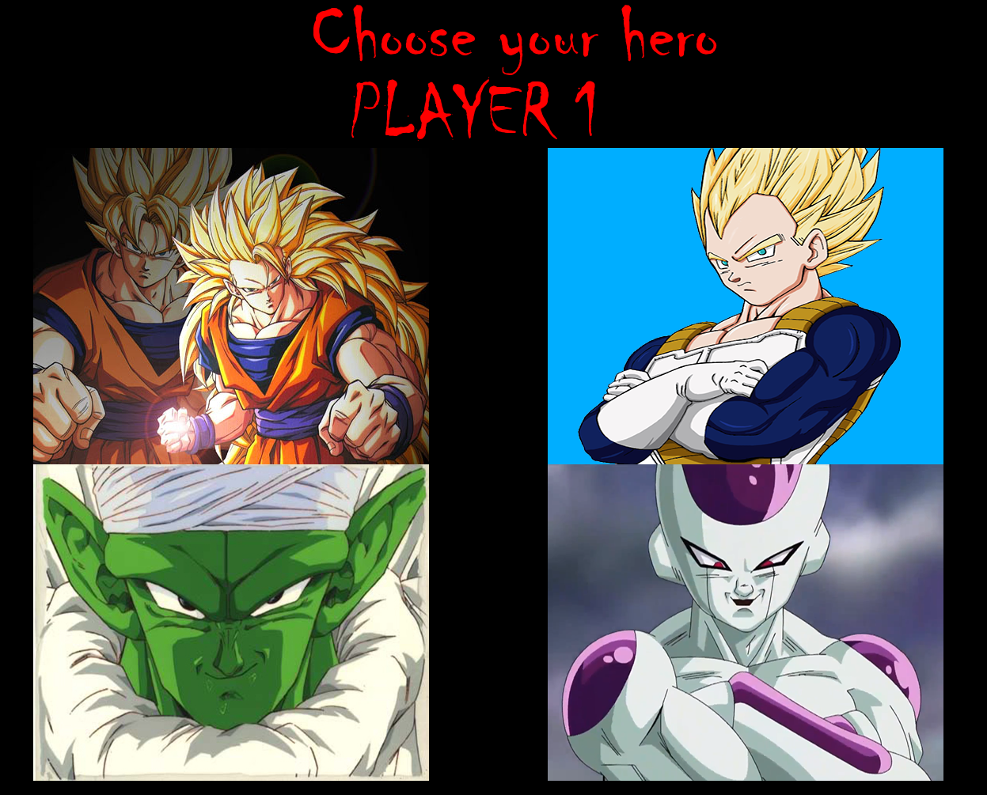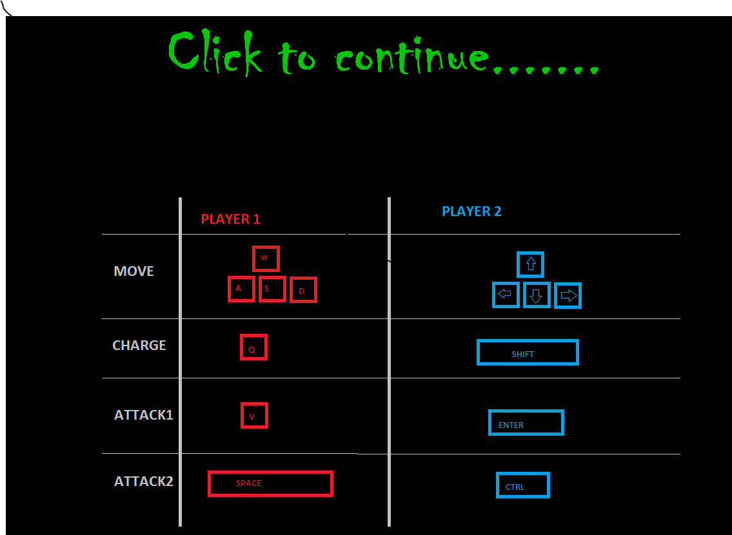

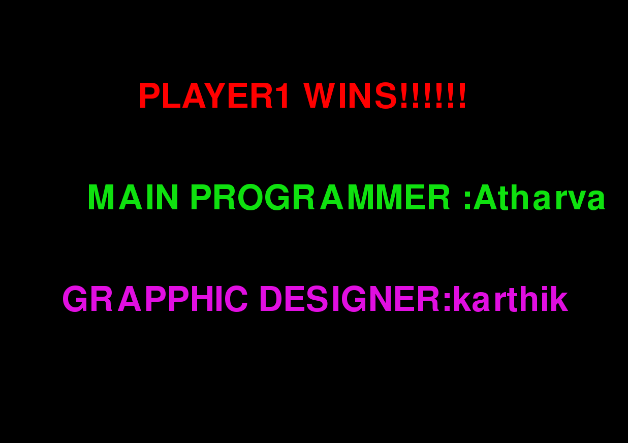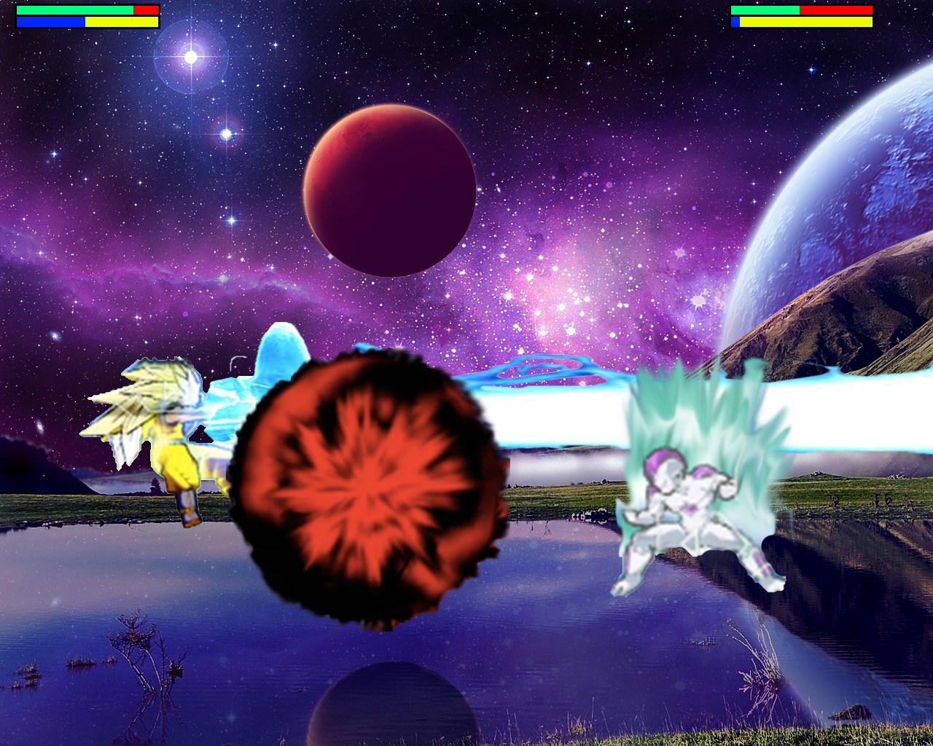

BIBLIOGRAPHY

* Pygame.org
* Dragon ball z :Shinbudokai